DIKIW Pyramid
The DIKIW Pyramid represents the structural evolution of understanding.
It describes how raw, meaningless input is transformed into high-level judgment.
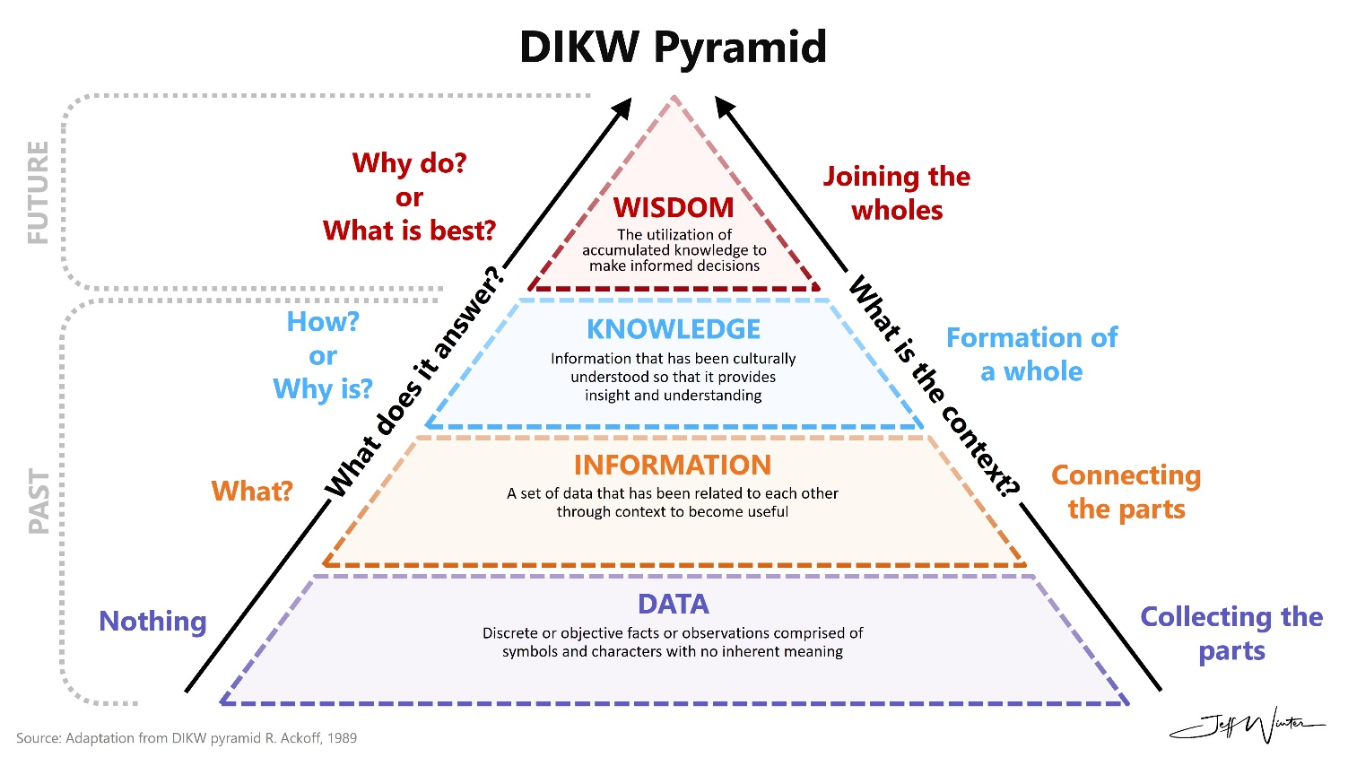

1. Data (The Raw Material)
Concept: Data is the base of the pyramid. It consists of symbols or signals that are unorganized and lack context. It is essentially "noise."
- The "101" Example: A sensor or a digital screen displays the number 101.
- Meaning: At this stage, we don't know if this is a price, a room number, or a score. It is just a digit.
- Machine State: The computer has stored this value in a memory address but cannot "process" it yet.
- The Learning State: No learning has occurred yet. This is simply storage.

2. Information (Data + Context)
Concept: Information is "useful" data. We achieve this stage by answering the questions: Who, What, Where, and When?
- The "101" Example: We attach a unit of measurement.
- "The reading on the thermometer(what) for Patient X(who) at 10:00 AM (when) at ward 4 of City Hospital(where) is 101°F."
- Meaning: The number now has a label. We know it refers to body temperature.
- Machine State: The system has performed Contextualizing.
- The Learning Action (Contextualizing): The system "learns" to associate the number with a unit of measurement.

3. Knowledge (Information + Pattern)
Concept: Knowledge is the application of experience to information. It answers the question: How? It identifies a relationship between the current information and a known standard.
- The "101" Example: Based on medical training, we know that the average human temperature is 98.6°F. Therefore, 101°F is a fever.
- Meaning: We have recognized a Pattern. We understand that this specific temperature indicates an abnormal physical state.
- Machine State: This is where Machine Learning lives. The algorithm compares the current "Information" against a "Training Set" of millions of other temperatures to identify the anomaly.
- The Learning Action (Pattern Recognition): This is where Machine Learning begins. The system compares current information against historical benchmarks to find a trend.

4. Intelligence (Knowledge + Action)
Concept: Intelligence is the active application of knowledge to achieve a goal. It is often the "missing link" in older versions of the pyramid. It answers the question: What should I do?
- The "101" Example: Because the patient has a fever, the system decides to administer paracetamol or send an alert to a nurse.
- Meaning: Knowledge has been turned into a Solution. We are no longer just observing; we are intervening.
- Machine State: This is the peak of Artificial Intelligence. The system uses logic or optimization to choose the best action to lower the temperature.
- The Learning Action (Optimization): The system learns which actions lead to the best results.

5. Wisdom (Intelligence + Judgment)
Concept: Wisdom is the highest level of understanding. It looks at the "Big Picture" and the long-term "Why." It involves ethics, deep experience, and reflection.
- The "101" Example: A wise doctor notices that the fever has spiked at 101°F for three consecutive days despite medicine. They conclude, "The fever is just a symptom; there is an underlying infection that needs a blood test."
- Meaning: Wisdom realizes that simply "fixing" the number 101 isn't enough. It seeks the Root Cause.
- Machine State: This is currently the most difficult stage for machines. It requires "Multi-domain Learning"—the ability to connect biology, history, and medical ethics.
- The Learning Action (Reflective Learning): Learning from the "Big Picture" and moral consequences.

Learning is the engine that moves us up this curve. If you stop learning, you fall back down to the 'Data' level, where you have lots of facts but no power to use them."
Level | Key Question | 101 Example Value | Core Process
Data | What? | 101 | Observation
Information | What/Who/Where/When? | 101°F (Fever) | Contextualization
Knowledge | How? | 101 > 98.6 (Abnormal) | Pattern Recognition
Intelligence | What to do? | Give Medicine | Action / Optimization
Wisdom | Why? | Is there an infection? | Evaluative Judgment

Example: Self-Driving Car
Level | Example in Autonomous Driving
Data | A pixel value of "Red" from the camera sensor.
Information | Recognizing that the "Red" is in the shape of an octagon on a pole.
Knowledge | Understanding that a red octagon means "Stop" based on traffic law training.
Intelligence | The car applies the brakes because it sees the stop sign and needs to stop.
Wisdom | Deciding to stop more gently because the road looks icy and a sudden brake might cause a skid.

1. Concept of Intelligence
Intelligence isn't just "knowing facts." It is the ability to acquire, understand, and apply knowledge to achieve a goal.
- In Humans: It involves reasoning, creativity, and emotional context.
- In Machines: It is the simulation of these processes—specifically the ability to find patterns in data and act on them.
2. Concept of Learning
Learning is the process by which intelligence is built. It is an adaptive change in behavior or knowledge based on experience.
- Biological Learning: Occurs via "synaptic plasticity" (neurons in your brain strengthening their connections).
- Machine Learning: Occurs via "mathematical optimization" (adjusting weights in an algorithm to reduce error).

The Human Learning Bridge (Cognitive)
Humans use Experience and Intuition to move from Knowledge to Wisdom. We learn from mistakes, ethics, and social context.
- Example: Learning that 101°F is dangerous through years of medical school and seeing patients.
The Machine Learning Bridge (Algorithmic)
Machines use Mathematics and Optimization to move from Data to Knowledge. They "learn" by identifying statistical patterns in Information.
- Example: An AI "learns" to identify a 101°F fever by looking at 10,000 health records and seeing that "101" correlates with "hospital stay."

Types of Machine Learning:
Type | Simple Analogy | Technical Definition
Supervised | Learning with a teacher. | Learning from "labeled" data (Input + Correct Answer).
Unsupervised | Finding patterns in a crowd. | Finding hidden structures in "unlabeled" data.
Reinforcement | Training a dog with treats. | Learning through trial and error to maximize a "reward."⁶

The Connection: AI vs. ML vs. DL
- Artificial Intelligence (AI): The broad field of creating "smart" machines.
- Machine Learning (ML): A subset of AI that focuses on learning from data without being explicitly programmed for every task.
- Deep Learning (DL): A subset of ML that uses Artificial Neural Networks (modeled after the human brain) to solve complex problems like image recognition.
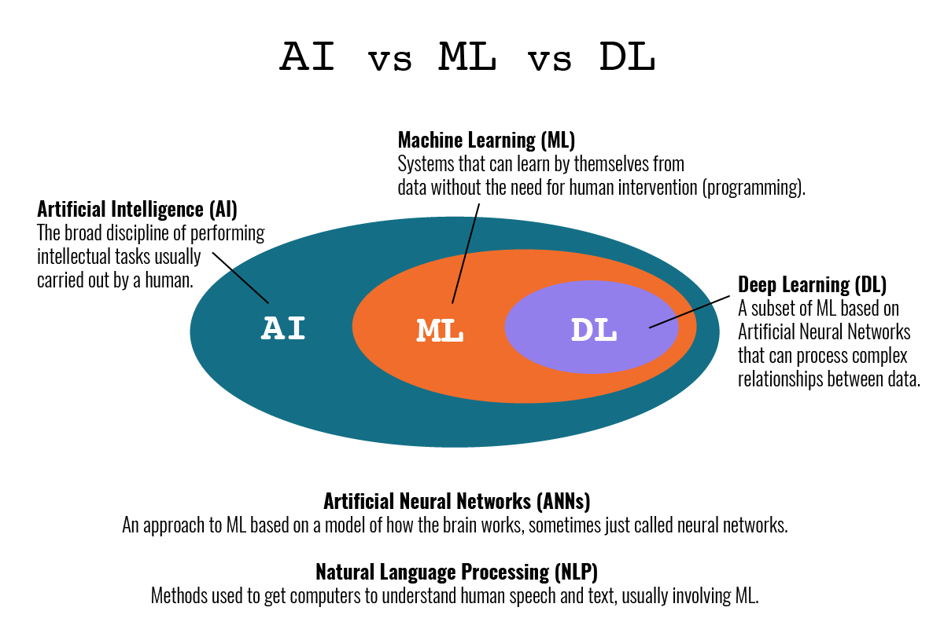
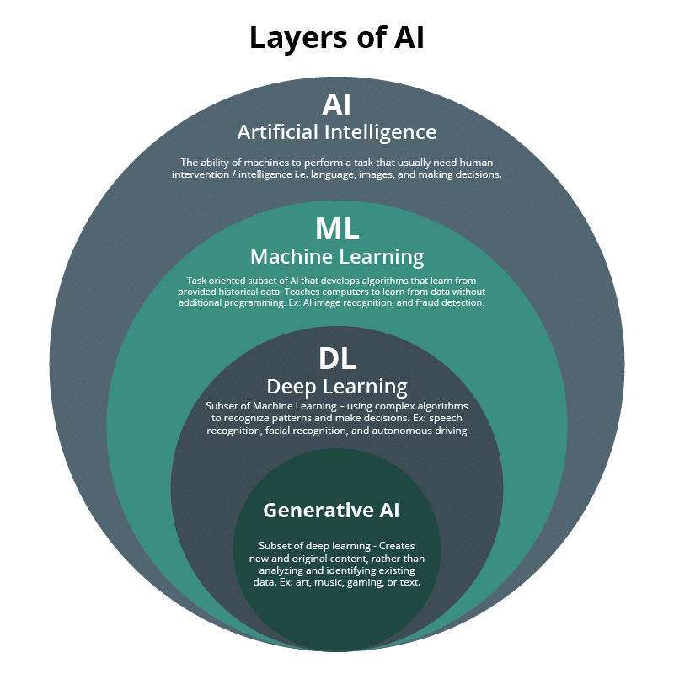
"Artificial Intelligence is a branch of computer science that deals with creating systems capable of performing tasks that typically require human intelligence, such as pattern recognition, learning, and decision-making."
John McCarthy, in 1956, coined the term “Artificial Intelligence”.

1. Alan Turing: The Father of AI (The Visionary)
Turing is called the "Father of AI" because he provided the theoretical foundation before modern computers even existed.
- The Big Question: In 1950, he published a paper titled "Computing Machinery and Intelligence," which opened with the radical question: "Can machines think?"
- The Turing Test: He moved the debate from "defining" intelligence to "measuring" it. He argued that if a machine could mimic a human so well that a judge couldn't tell the difference, it should be considered "intelligent."
- Universal Computation: He invented the "Turing Machine" concept, proving that a machine could be programmed to solve any problem that is mathematically solvable.
- Biological Inspiration: As early as 1948, he wrote about "unorganized machines" that would be trained rather than programmed—the earliest conceptual ancestor to Neural Networks.
Summary: He gave AI its Goal and its Philosophy.

2. Arthur Samuel: The Father of ML (The Builder)
While Turing was a theorist, Samuel was a practitioner. He proved that machines could actually learn and improve on their own.
- Coined the Term: In 1959, he officially named the field "Machine Learning." * The Checkers Program: This was the world's first successful self-learning program. He didn't just code the rules of checkers; he made the program play against itself thousands of times to "discover" winning strategies.
- Proving Superiority: In 1962, his program defeated a human checkers master. This was a "lightbulb moment" for the world: it proved that a computer could become better than the person who programmed it.
- Technical Firsts: He introduced Alpha-Beta Pruning and Heuristic Search—techniques that are still taught in every AI course today to help computers make faster decisions.
Summary: He gave ML its Process and its First Proof of Success.

Feature | Alan Turing (AI) | Arthur Samuel (ML)
Focus | Could a machine think? | Could a machine learn?
Primary Contribution | The Turing Test (Philosophy) | Checkers Program (Execution)
Key Insight | Anything computable can be automated. | Machines can improve through experience.
Role in History | Defined the "Mind." | Defined the "Method."

Technical Definition Comparison:
Feature | Artificial Intelligence (AI) | Machine Learning (ML)
Official Definition | "Making machines intelligent." | "Learning without being explicitly programmed."
Logic Type | Can be Rule-based or Learning-based. | Strictly Learning-based.
Data Usage | Does not always need data (e.g., Expert Systems). | Requires Data (Experience) to function.
Key Scientist | John McCarthy | Arthur Samuel
Analogy | The Car (The final product). | The Engine (What makes it move).

Easiest way to tell the difference:
- If I write 1,000 lines of code saying 'If the patient has X, then do Y,' I have created AI, but I have not used Machine Learning. Why? Because I, the human, provided all the logic.
- If I give the computer 1,000 patient files and say 'Figure out the logic yourself,' that is Machine Learning."

Checklist: Which is it?
- A calculator? Neither. It’s just an arithmetic processor.
- A thermostat that turns on at 70°F? Simple Automation (No AI).
- A video game enemy that hides when it sees you? AI (Behavioral).
- Amazon recommending a book based on your past buys? AI powered by Machine Learning.

TEP (Task, Experience, Performance) framework:
This was introduced by Tom Mitchell, another giant in ML, to provide a formal mathematical structure for "Learning."
Definition of Learning (TEP): A computer program is said to learn from Experience (E) with respect to some class of Tasks (T) and Performance measure (P), if its performance at tasks in T, as measured by P, improves with experience E.
Think of TEP as the "Recipe for Learning." If a computer doesn't have all three of these ingredients, it isn't "Machine Learning"—it’s just a regular program.

The "Formula"
A computer is learning if it gets better at a Task (T), because of Experience (E), and you can prove it with a Performance Measure (P).
1. Task (T)
- What is the goal?
- It is the specific problem the computer is trying to solve.
- Example: Identifying if an email is "Spam."
2. Experience (E)
- What is the data?
- It is the "history" or the "practice" the computer goes through.
- Example: Looking at 5,000 previous emails that were already marked as Spam.
3. Performance (P)
- How do we score it?
- It is a number (a percentage or a score) that tells us if the computer is actually getting smarter.
- Example: The percentage of spam emails correctly caught (e.g., 95% accuracy)

1. Supervised Learning Examples (Labeled Data)
The machine is told the "Right Answer" during training.
Task (T) | Experience (E) | Performance (P)
Email Spam Detection | 10,000 emails labeled as "Spam" or "Not Spam." | % of emails correctly filtered.
House Price Prediction | Dataset of house sizes and their actual selling prices. | Accuracy of price (Mean Squared Error).
Medical Diagnosis | 5,000 X-rays labeled with "Tumor" or "Healthy." | Ability to correctly identify a tumor.
Handwriting Recognition | Images of handwritten digits matched with their values (0-9). | % of digits correctly recognized.
Credit Scoring | Past bank data of users who defaulted vs. those who paid. | Ability to predict if a new user will pay back.

2. Unsupervised Learning Examples (No Labels)
The machine finds hidden patterns on its own.
Task (T) | Experience (E) | Performance (P)
Customer Segmentation | List of shopping habits of 1 million users. | Similarity of users within the same "cluster."
Genetics Research | DNA sequences from various species. | Grouping species with similar DNA traits.
Anomaly Detection | Normal credit card transaction logs. | Identifying a transaction that looks "unusual."
Document Clustering | 10,000 news articles without categories. | Grouping articles by similar topics (Sports, Tech).
Image Compression | A high-resolution photo. | Reducing file size while keeping visual quality.

3. Reinforcement Learning Examples (Rewards/Penalties)
The machine learns through trial and error in an environment.
Task (T) | Experience (E) | Performance (P)
Self-Driving Car | Driving on a simulated track. | Distance traveled without crashing (Reward).
Chess AI | Playing millions of games against itself. | Winning percentage against human masters.
Robot Arm Pick-up | Trying to grab a ball in a warehouse. | Number of successful "grabs" per hour.
Stock Trading | Historical market fluctuations. | Total profit made over a fiscal quarter.
Game Playing (Mario) | Jumping over obstacles and collecting coins. | Final score reached at the end of the level.

